Software Design Description

Design Overview
- The architectural design describes the overall architecture of the system and the architecture of each main component and subsystem.
- The detailed design describes static and dynamic structure for each component and functions. It includes class diagrams, class explanations and sequence diagrams for each use cases.
- The database design describes the relationships between entities and details of each entity.
- Document overview:
- Section 1: gives an overall description of the system architecture design.
- Section 2: gives component diagrams that describe the connection and integration of the system.
- Section 3: gives the detail design description, which includes class diagram, class explanation, and sequence diagram to details the application functions.
- Section 4: gives the interface design description, which includes component interface, web application interface and mobile application design.
- Section 5: describe a fully attributed Entity Relationship Diagram.
- Section 6: describe the algorithms that apply to the system.

System Architectural Design

Web Application Architecture Description
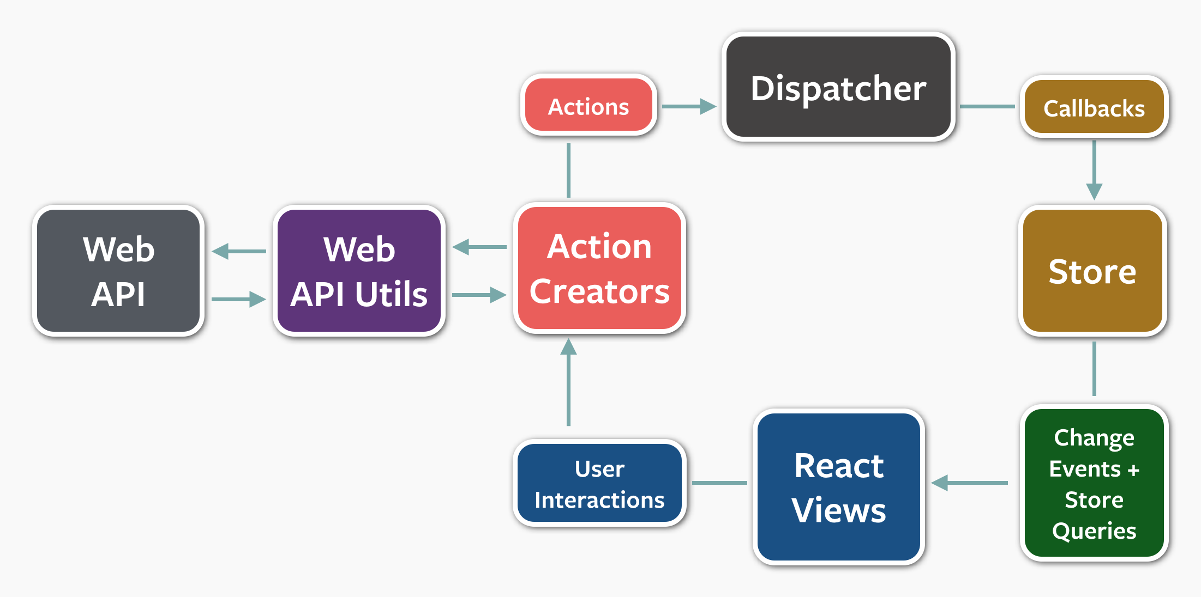

(Image source: https://facebook.github.io/react/blog/2014/07/30/flux-actions-and-the-dispatcher.html)

Figure 36: Web Application Architecture

The web application uses React (https://facebook.github.io/react/) with Flux (https://facebook.github.io/flux/) as its architecture. Flux creates a unidirectional data flow for web applications built with React. We choose this architecture for a couple of reasons:
- Performance: The web application’s render performance is dramatically improved thanks to React. React renders the web application with the help of its virtual DOM. Each React view component has a render method, which will update the virtual DOM. React then compares the updated virtual DOM with a virtual DOM snapshot that was taken right before the update. By doing so, React figures out exactly which virtual DOM objects have change, and only updates those different objects on the real DOM.
- Simplicity: the whole web application is simple to develop and maintain, because the data always flows in one direction. There is no need to handle event listener for each web component like in MVC application. This architecture also separates frontend from backend, so developers are able to work independently.
- Reusability and Testability: The architecture divides the application into components. This increases reusability and testability.

Web Service Application Architecture Description
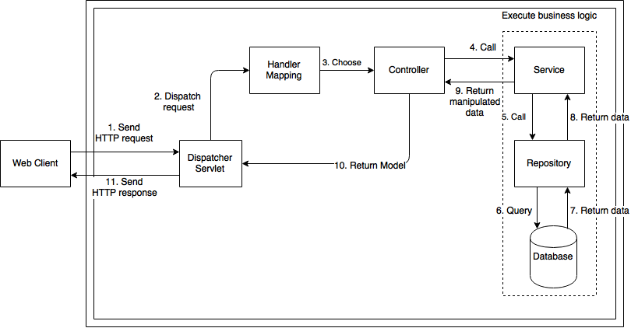

Figure 37: Web Service Architecture

The Web Service Application Architecture uses Spring MVC architecture (https://docs.spring.io/spring/docs/current/spring-framework-reference/html/mvc.html). We choose this Spring MVC for the following advantages:
- MVC: The application will be divided into three clear parts: Model – View – Controller, thus makes it easier for developing, testing, and maintaining.
- Availability: Spring MVC framework supports automatic mapping from Dispatcher Servlet to Controller, Controller to Model map with wanted data, and many more advantages. Therefore, the development process is greatly reduced.

Component Diagram

Detail Description

Class Diagram

Class Diagram Explanation

Interaction Diagram

Mobile Application

<Unauthorized User> Login
Summary: these diagrams show the process of unauthorized user login into the system using mobile application

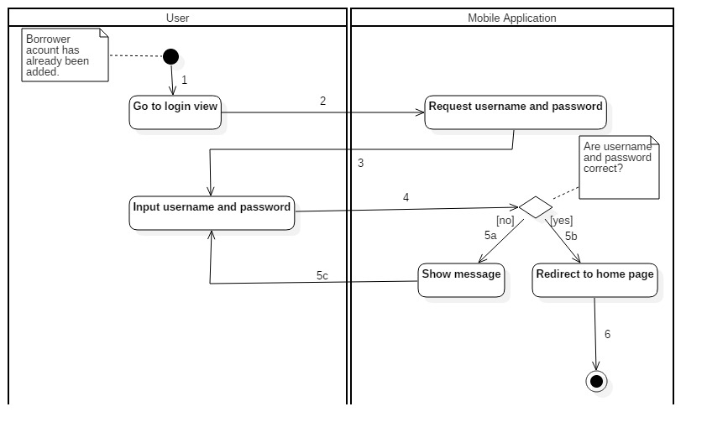
Figure 1: Activity Diagram - <Unauthorized User> Login
1. Start | 2. Go to Login view | 3. Request email and password
4. Input email and password | 5a. Correct email and password | 5b. Incorrect email and password
5c. Input email and password again | 6. Redirect to home page and finish

<Borrower> Check in with NFC
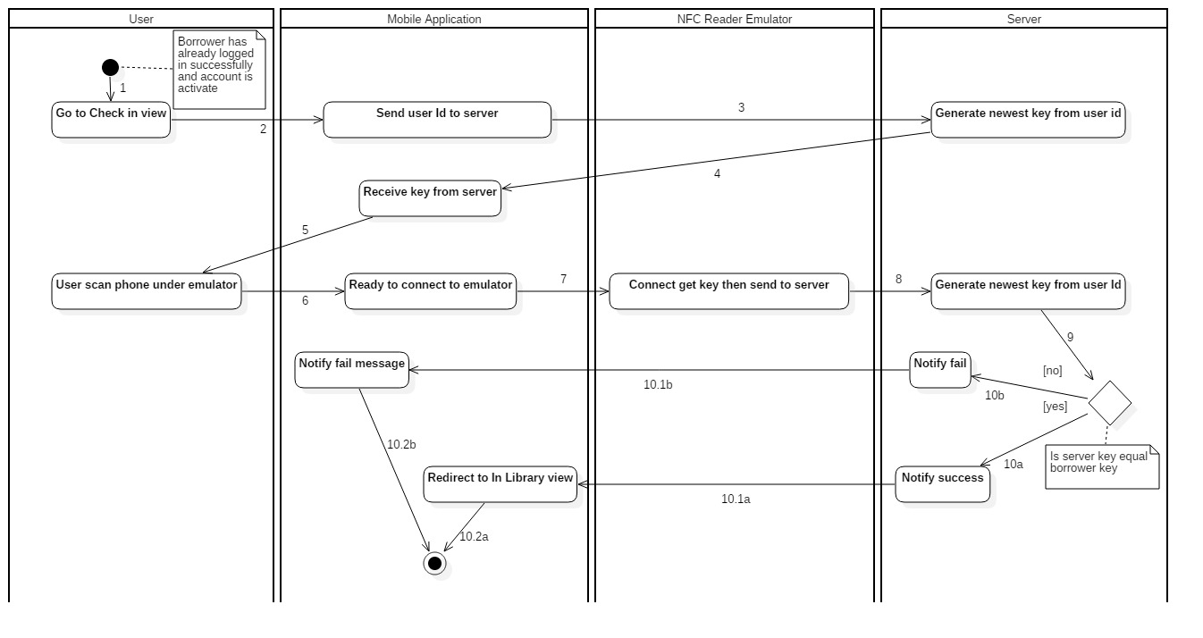 Figure 2: Activity Diagram - <Borrower> Check in with NFC

1. Start. | 2. Go to Check in view. | 3. Send user Id to server.
4. Generate newest key from user id. | 5. Receive key from server. | 6. User scan phone under emulator.
7. Borrower phone is ready to connect to emulator. | 8. Emulator connect, get key then send to server. | 9. Generate newest key from user Id.
10b. Key from user and server are not equal. | 10.1b. Notify check in fail to borrower. | 10a. Key from user and server are equal.
10.1a. Borrower phone redirect to In Library view.

<Borrower> Check in with QR Code
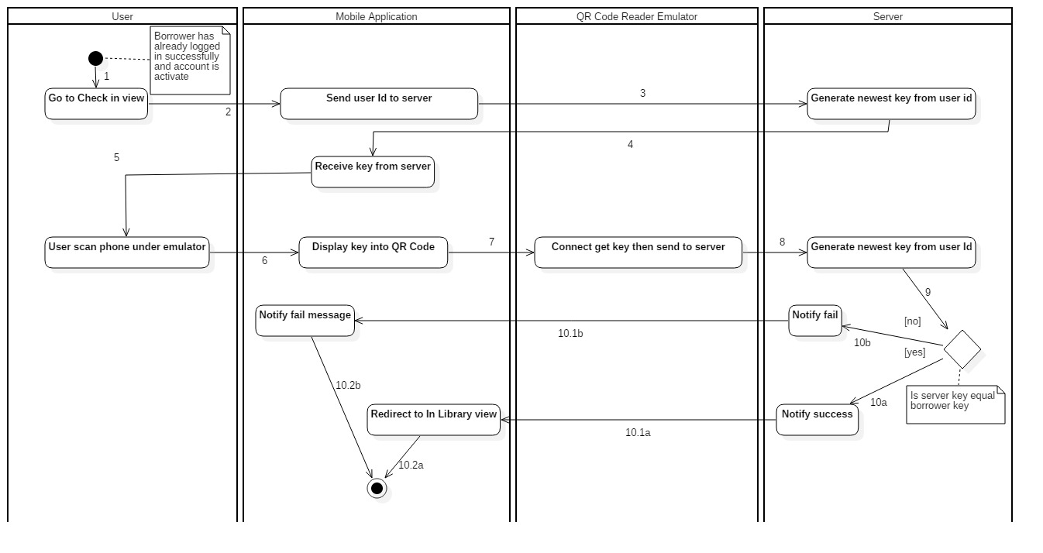
Figure 3: Activity Diagram - <Borrower> Check in with QR Code
1. Start. | 2. Go to Check in view. | 3. Send user Id to server.
4. Generate newest key from user id. | 5. Receive key from server. | 6. User scan phone under emulator.
7. Borrower phone display key into QR Code. | 8. Emulator connect, get key then send to server. | 9. Generate newest key from user Id.
10b. Key from user and server are not equal. | 10.1b. Notify check in fail to borrower. | 10a. Key from user and server are equal.
10.1a. Borrower phone redirect to In Library view.

<Borrower> Check out

Interface

Database Design

Algorithms

Check-in Algorithms

Definition
Token authentication is a technique to prove that the passengers is who they claim to be. Requests which have the right token will be processed.

Define the problem
When the borrower use mobile application to check in. Mobile application sends some information to emulator for verification, we have to make sure that the information only valid in a specific time for checking in.

Solution
To solve this problem, we should follow these steps:
- Mobile application send a request for private key before checking – in.
- Server generate key base on user id and time then send to mobile application.
- When borrower check-in, emulator get user and key from mobile application.
- Server generate key base on user id then compare with key sent from emulator, if it matchs current server token, request will be processed.

